Menelaus' Theorem
# Source: AI Source: Provided by: [Data Path: Persons Table -> ID Column: 1, Name_En Column: Motasem Essam] -> From: [ChatGPT] on [7/25/2026]
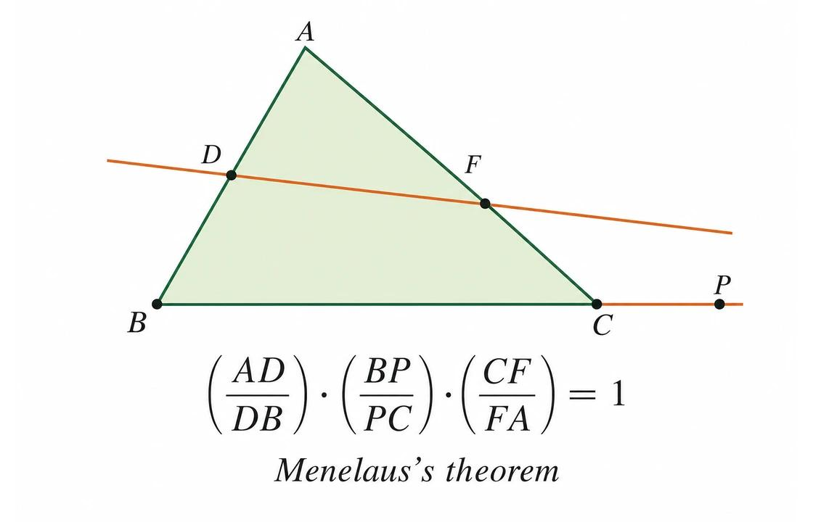
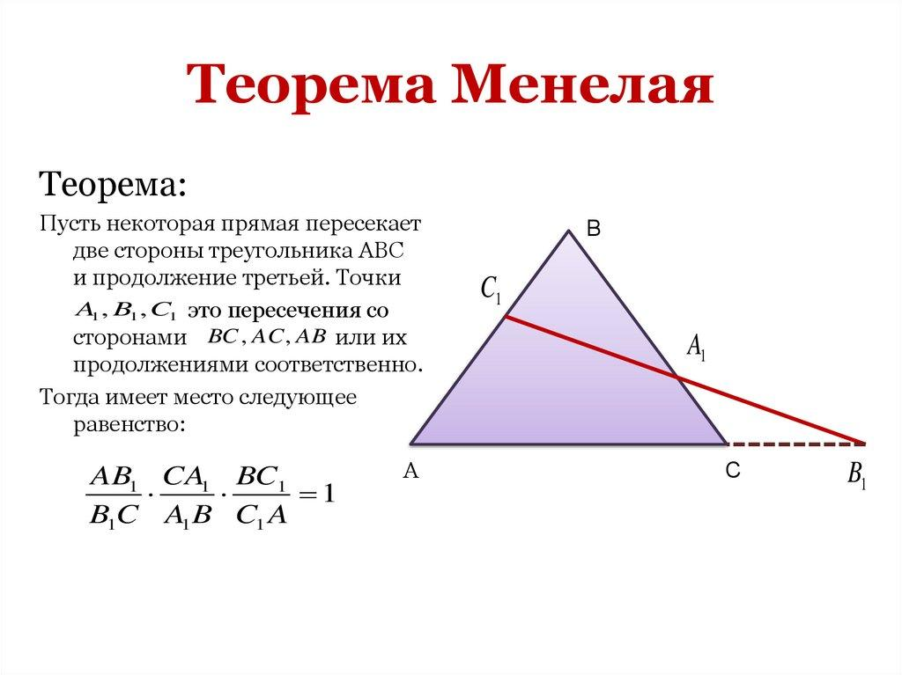
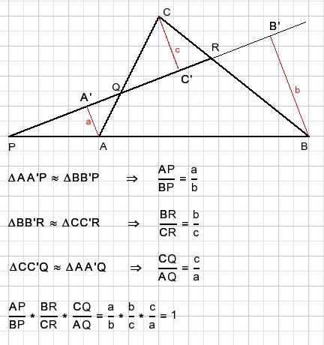
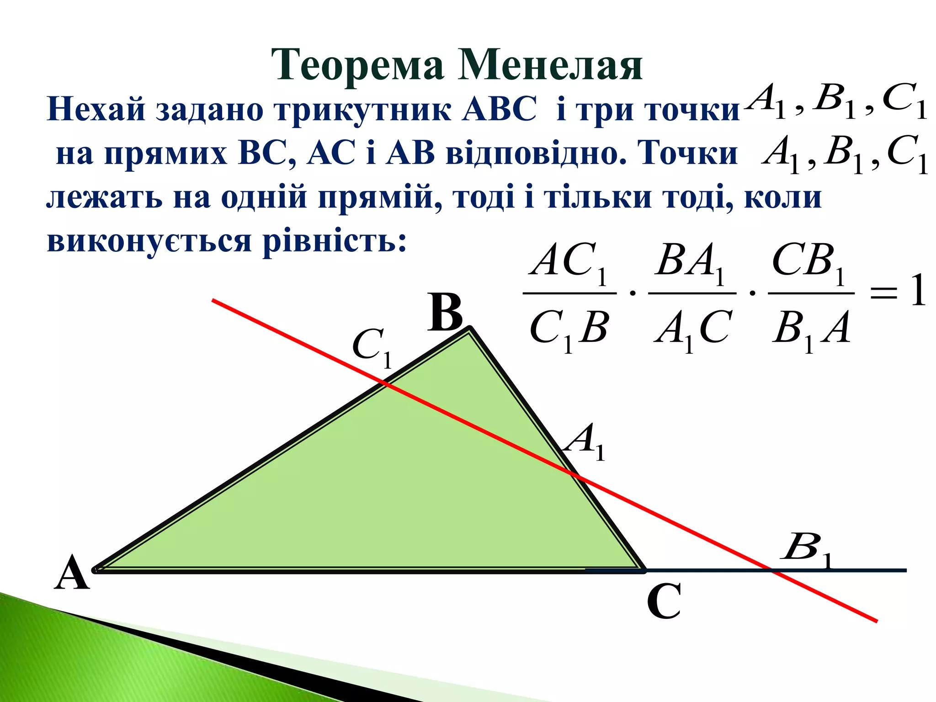

Definition
# Source: AI Source: Provided by: [Data Path: Persons Table -> ID Column: 1, Name_En Column: Motasem Essam] -> From: [ChatGPT] on [7/25/2026]
Menelaus' Theorem is a theorem in triangle geometry that gives a condition for determining whether three points on the sides of a triangle, or on their extensions, are collinear.
For triangle $△ABC$, let:
- $D$lie on $BC$or its extension,
- $E$lie on $CA$or its extension,
- $F$lie on $AB$or its extension.
Then $D,E,F$are collinear if and only if, using directed lengths,
$$\boxed{\frac{\overset{‾}{BD}}{\overset{‾}{DC}}⋅\frac{\overset{‾}{CE}}{\overset{‾}{EA}}⋅\frac{\overset{‾}{AF}}{\overset{‾}{FB}}=-1}$$
This is the standard directed-length form of Menelaus' Theorem.
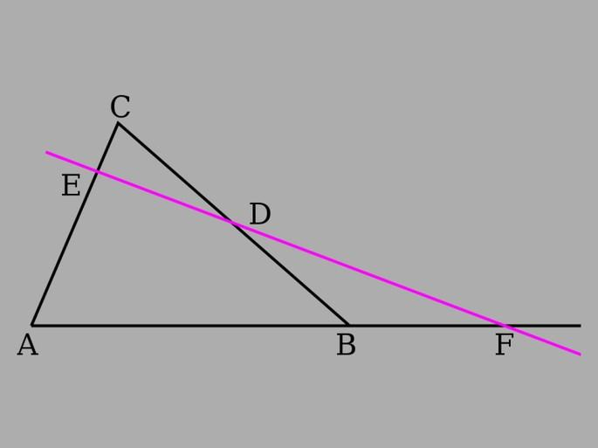
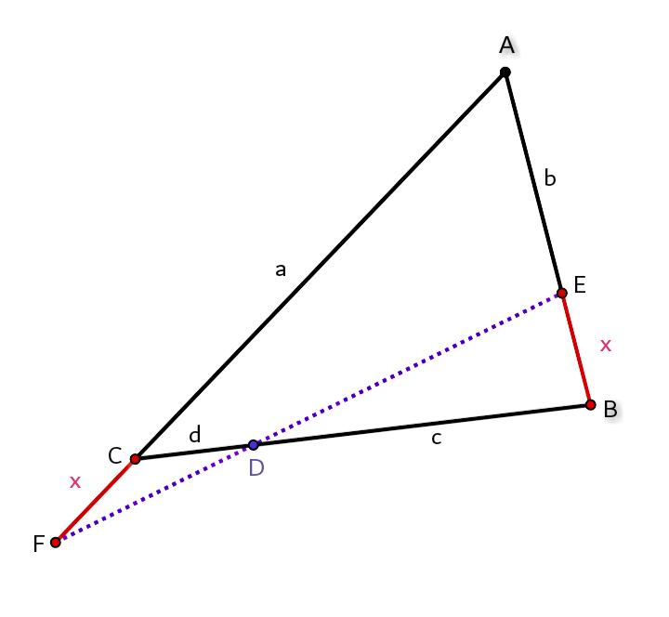

Simple Definition
# Source: AI Source: Provided by: [Data Path: Persons Table -> ID Column: 1, Name_En Column: Motasem Essam] -> From: [ChatGPT] on [7/25/2026]
Menelaus' Theorem tells us when three points located on the sides or extensions of a triangle lie on one straight line.
The central idea is:
$$\boxed{\text{Three Points Are Collinear }⟺\text{ Product of Three Directed Ratios}=-1}$$

Fundamental Configuration
# Source: AI Source: Provided by: [Data Path: Persons Table -> ID Column: 1, Name_En Column: Motasem Essam] -> From: [ChatGPT] on [7/25/2026]
Consider $△ABC$and a line passing through the three points $D,E,F$:
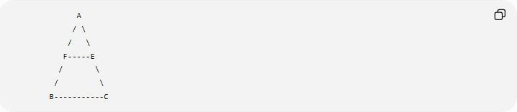
A
/ \
/ \
F-----E
/ \
/ \
B-----------C
Here:
$$F∈AB, E∈AC, D∈BC$$
and $D,E,F$lie on the same straight line.
That line is called a transversal of the triangle.
A more general configuration may have the transversal crossing extensions of the sides:
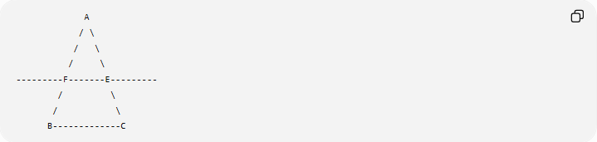
A
/ \
/ \
/ \
---------F-------E---------
/ \
/ \
B-------------C
The exact position of the points determines the signs of the directed lengths.

Statement of Menelaus' Theorem
# Source: AI Source: Provided by: [Data Path: Persons Table -> ID Column: 1, Name_En Column: Motasem Essam] -> From: [ChatGPT] on [7/25/2026]
For $△ABC$, with $D,E,F$lying on the corresponding sides or their extensions:
$$\boxed{D,E,F\text{ are collinear }⟺ \frac{\overset{‾}{BD}}{\overset{‾}{DC}}⋅\frac{\overset{‾}{CE}}{\overset{‾}{EA}}⋅\frac{\overset{‾}{AF}}{\overset{‾}{FB}}=-1}$$
The use of directed lengths is important because some points may lie outside the triangle.

What Is a Transversal?
# Source: AI Source: Provided by: [Data Path: Persons Table -> ID Column: 1, Name_En Column: Motasem Essam] -> From: [ChatGPT] on [7/25/2026]
A transversal is a line that intersects two or more other lines.
In Menelaus' Theorem, the transversal intersects the three sides of a triangle or their extensions.
For example:
$$\boxed{D,E,F\text{ are on one line}}$$
means that the line $DEF$intersects:
- $BC$at $D$,
- $CA$at $E$,
- $AB$at $F$.

The Main Idea
# Source: AI Source: Provided by: [Data Path: Persons Table -> ID Column: 1, Name_En Column: Motasem Essam] -> From: [ChatGPT] on [7/25/2026]
Menelaus connects:
Geometric condition
$$\boxed{D,E,F\text{ are collinear}}$$
with:
Algebraic condition
$$\boxed{\frac{\overset{‾}{BD}}{\overset{‾}{DC}}\frac{\overset{‾}{CE}}{\overset{‾}{EA}}\frac{\overset{‾}{AF}}{\overset{‾}{FB}}=-1}$$
Therefore:
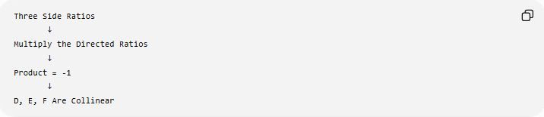
Three Side Ratios
↓
Multiply the Directed Ratios
↓
Product = -1
↓
D, E, F Are Collinear

Why Directed Lengths Are Needed
# Source: AI Source: Provided by: [Data Path: Persons Table -> ID Column: 1, Name_En Column: Motasem Essam] -> From: [ChatGPT] on [7/25/2026]
This is one of the most important aspects of Menelaus' Theorem.
Suppose all three points are inside the triangle. Then the ordinary positive lengths give:
$$\frac{BD}{DC}>0, \frac{CE}{EA}>0, \frac{AF}{FB}>0$$
so their product cannot literally be $-1$.
This is why the theorem is normally stated using directed segments.
A point lying on an extension of a side produces a negative directed ratio according to the chosen orientation.
Thus the signed formula becomes:
$$\boxed{-1}$$
rather than simply $1$.

Example 1: Basic Collinearity Test
# Source: AI Source: Provided by: [Data Path: Persons Table -> ID Column: 1, Name_En Column: Motasem Essam] -> From: [ChatGPT] on [7/25/2026]
Suppose:
$$\frac{\overset{‾}{BD}}{\overset{‾}{DC}}=-\frac{2}{3} \\ \frac{\overset{‾}{CE}}{\overset{‾}{EA}}=-\frac{3}{4}$$
and:
$$\frac{\overset{‾}{AF}}{\overset{‾}{FB}}=-\frac{2}{1}$$
Then:
$$\left(-\frac{2}{3}\right)\left(-\frac{3}{4}\right)\left(-2\right)$$
First:
$$\left(-\frac{2}{3}\right)\left(-\frac{3}{4}\right)=\frac{1}{2}$$
Then:
$$\frac{1}{2}\left(-2\right)=-1$$
Therefore:
$$\boxed{D,E,F\text{ are collinear}}$$
by Menelaus' Theorem.

Example 2: Finding an Unknown Ratio
# Source: AI Source: Provided by: [Data Path: Persons Table -> ID Column: 1, Name_En Column: Motasem Essam] -> From: [ChatGPT] on [7/25/2026]
Suppose:
$$\frac{\overset{‾}{BD}}{\overset{‾}{DC}}=-\frac{2}{3}$$
and
$$\frac{\overset{‾}{CE}}{\overset{‾}{EA}}=-\frac{4}{5}$$
Find:
$$\frac{\overset{‾}{AF}}{\overset{‾}{FB}}$$
if $D,E,F$are collinear.
By Menelaus:
$$\frac{2}{3}⋅\frac{4}{5}⋅\frac{\overset{‾}{AF}}{\overset{‾}{FB}}=-1$$
Therefore:
$$\frac{8}{15}\frac{\overset{‾}{AF}}{\overset{‾}{FB}}=-1$$
so:
$$\boxed{\frac{\overset{‾}{AF}}{\overset{‾}{FB}}=-\frac{15}{8}}$$
The negative sign reflects the directed-length convention.

Example 3: Testing Collinearity
# Source: AI Source: Provided by: [Data Path: Persons Table -> ID Column: 1, Name_En Column: Motasem Essam] -> From: [ChatGPT] on [7/25/2026]
Suppose the directed ratios are:
$$\frac{\overset{‾}{BD}}{\overset{‾}{DC}}=-2 \\ \frac{\overset{‾}{CE}}{\overset{‾}{EA}}=-3 \\ \frac{\overset{‾}{AF}}{\overset{‾}{FB}}=-\frac{1}{6}$$
Then:
$$\left(-2\right)\left(-3\right)\left(-\frac{1}{6}\right) \\ =6\left(-\frac{1}{6}\right) \\ =-1$$
Therefore:
$$\boxed{D,E,F\text{ are collinear}}$$

Converse of Menelaus' Theorem
# Source: AI Source: Provided by: [Data Path: Persons Table -> ID Column: 1, Name_En Column: Motasem Essam] -> From: [ChatGPT] on [7/25/2026]
Menelaus' Theorem also works in the converse direction.
If:
$$\boxed{\frac{\overset{‾}{BD}}{\overset{‾}{DC}}\frac{\overset{‾}{CE}}{\overset{‾}{EA}}\frac{\overset{‾}{AF}}{\overset{‾}{FB}}=-1}$$
then:
$$\boxed{D,E,F\text{ are collinear}}$$
Thus:
$$\boxed{D,E,F\text{ collinear }⟺\text{ ratio product}=-1}$$

Proof Idea
# Source: AI Source: Provided by: [Data Path: Persons Table -> ID Column: 1, Name_En Column: Motasem Essam] -> From: [ChatGPT] on [7/25/2026]
One common proof uses similar triangles or area relationships.
Consider a transversal crossing the sides of a triangle. By comparing triangles that share altitudes, ratios of corresponding side segments can be related.
For example, ratios such as:
$$\frac{BD}{DC}$$
can be expressed through ratios of areas.
Multiplying the three resulting relationships causes the intermediate quantities to cancel, leaving:
$$\frac{\overset{‾}{BD}}{\overset{‾}{DC}}⋅\frac{\overset{‾}{CE}}{\overset{‾}{EA}}⋅\frac{\overset{‾}{AF}}{\overset{‾}{FB}}=-1$$
The negative sign comes from the directed-segment orientation.

Menelaus' Theorem vs Ceva's Theorem
# Source: AI Source: Provided by: [Data Path: Persons Table -> ID Column: 1, Name_En Column: Motasem Essam] -> From: [ChatGPT] on [7/25/2026]
These two theorems are closely related and are often studied together.
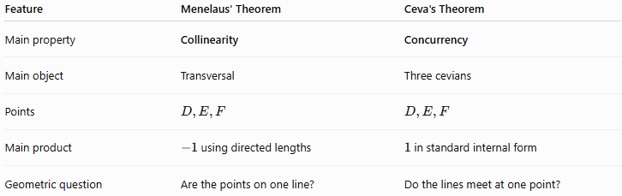
Feature | Menelaus' Theorem | Ceva's Theorem
Main property | Collinearity | Concurrency
Main object | Transversal | Three cevians
Points | $$D,E,F$$ | $$D,E,F$$
Main product | $-1$using directed lengths | $1$in standard internal form
Geometric question | Are the points on one line? | Do the lines meet at one point?
The central distinction is:
$$\boxed{\text{Menelaus}→\text{Collinearity}} \\ \boxed{\text{Ceva}→\text{Concurrency}}$$

Visual Comparison
# Source: AI Source: Provided by: [Data Path: Persons Table -> ID Column: 1, Name_En Column: Motasem Essam] -> From: [ChatGPT] on [7/25/2026]
Menelaus
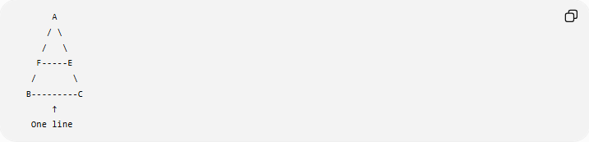
A
/ \
/ \
F-----E
/ \
B---------C
↑
One line
Three points lie on one line:
$$\boxed{D,E,F\text{ are collinear}}$$

Ceva
# Source: AI Source: Provided by: [Data Path: Persons Table -> ID Column: 1, Name_En Column: Motasem Essam] -> From: [ChatGPT] on [7/25/2026]
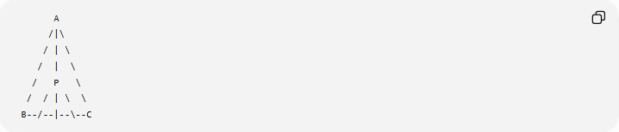
A
/|\
/ | \
/ | \
/ P \
/ / | \ \
B--/--|--\--C
Three cevians meet at one point:
$$\boxed{AD, BE, CF\text{ are concurrent}}$$

Relationship Between Menelaus and Ceva
# Source: AI Source: Provided by: [Data Path: Persons Table -> ID Column: 1, Name_En Column: Motasem Essam] -> From: [ChatGPT] on [7/25/2026]
They can be viewed as complementary triangle theorems:
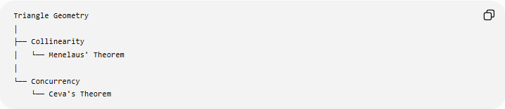
Triangle Geometry
│
├── Collinearity
│ └── Menelaus' Theorem
│
└── Concurrency
└── Ceva's Theorem
They both use ratios of segments on the sides of a triangle, but they answer different geometric questions.

Applications
# Source: AI Source: Provided by: [Data Path: Persons Table -> ID Column: 1, Name_En Column: Motasem Essam] -> From: [ChatGPT] on [7/25/2026]
Menelaus' Theorem can be used to:
- prove that three points are collinear;
- test whether points lie on one straight line;
- find an unknown side ratio;
- solve triangle-transversal problems;
- analyze points on extensions of triangle sides;
- establish geometric relationships involving transversals;
- solve advanced Euclidean geometry problems.

Important Conditions
# Source: AI Source: Provided by: [Data Path: Persons Table -> ID Column: 1, Name_En Column: Motasem Essam] -> From: [ChatGPT] on [7/25/2026]
For the standard theorem:
- $A,B,C$form a triangle.
- $D,E,F$lie on the corresponding sides or their extensions.
- Directed lengths are used when points lie on extensions.
- The three points are collinear exactly when the ratio product satisfies the theorem.

Classification
# Source: AI Source: Provided by: [Data Path: Persons Table -> ID Column: 1, Name_En Column: Motasem Essam] -> From: [ChatGPT] on [7/25/2026]
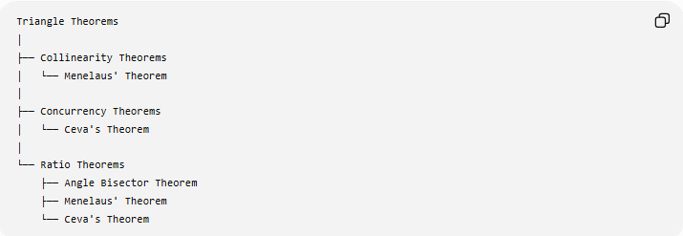
Triangle Theorems
│
├── Collinearity Theorems
│ └── Menelaus' Theorem
│
├── Concurrency Theorems
│ └── Ceva's Theorem
│
└── Ratio Theorems
├── Angle Bisector Theorem
├── Menelaus' Theorem
└── Ceva's Theorem

Key Formula
# Source: AI Source: Provided by: [Data Path: Persons Table -> ID Column: 1, Name_En Column: Motasem Essam] -> From: [ChatGPT] on [7/25/2026]
For $△ABC$:
$$D∈BC, E∈CA, F∈AB$$
using directed lengths:
$$\boxed{D,E,F\text{ are collinear }⟺ \frac{\overset{‾}{BD}}{\overset{‾}{DC}}⋅\frac{\overset{‾}{CE}}{\overset{‾}{EA}}⋅\frac{\overset{‾}{AF}}{\overset{‾}{FB}}=-1}$$

Key Points
# Source: AI Source: Provided by: [Data Path: Persons Table -> ID Column: 1, Name_En Column: Motasem Essam] -> From: [ChatGPT] on [7/25/2026]
- Menelaus' Theorem concerns collinearity.
- It involves a triangle and a transversal.
- The three relevant points are $D,E,F$.
- The standard directed-length formula is:
$$\boxed{\frac{\overset{‾}{BD}}{\overset{‾}{DC}}\frac{\overset{‾}{CE}}{\overset{‾}{EA}}\frac{\overset{‾}{AF}}{\overset{‾}{FB}}=-1}$$
- Directed lengths are important when points lie on side extensions.
- The theorem has a converse.
- Ceva's Theorem concerns concurrency, while Menelaus' Theorem concerns collinearity.
- Both are important ratio theorems in triangle geometry.

Conclusion
# Source: AI Source: Provided by: [Data Path: Persons Table -> ID Column: 1, Name_En Column: Motasem Essam] -> From: [ChatGPT] on [7/25/2026]
Menelaus' Theorem provides an algebraic condition for determining whether three points associated with the sides of a triangle lie on one straight line:
$$\boxed{\text{Three Points Collinear }⟺\text{ Product of Directed Ratios}=-1}$$
Its central relationship is:
$$\boxed{\text{Side Ratios}⟷\text{Collinearity}}$$
It forms a natural pair with Ceva's Theorem:
$$\boxed{\text{Menelaus}=\text{Collinearity} \text{Ceva}=\text{Concurrency}}$$

